Privacy Policy
Effective Date: June 1, 2026
At Globe Market Research, quality research is built on trust, accuracy, and responsible data handling. This Privacy Policy explains how we collect, use, store, and protect information when users visit our website, contact us, request a sample report, purchase a research report, subscribe to updates, or use our research and consulting services.
By using our website or sharing information with us, users agree to the practices described in this Privacy Policy. We aim to keep our data practices clear, fair, and transparent so that clients, visitors, and business partners can understand how their information is managed.
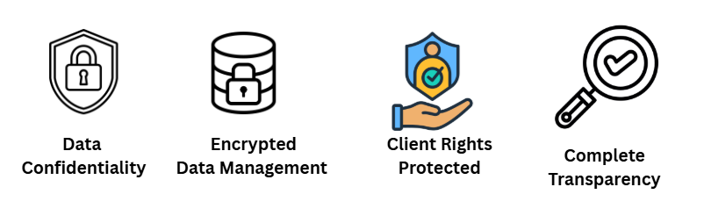
Information We Collect
We may collect basic personal and business information when users interact with our website or services. This may include name, company name, job title, email address, phone number, country, billing details, inquiry details, and communication preferences.
We may also collect non-personal technical information such as browser type, device information, IP address, pages visited, time spent on the website, traffic source, and general website usage patterns. This information helps us improve website performance, user experience, and service quality.
How We Use Information?
The information collected may be used to respond to inquiries, deliver requested reports, process payments, provide customer support, share relevant business updates, and improve our research offerings. It may also be used to understand client requirements and provide suitable research solutions.
We may use website usage data to improve content structure, website navigation, report visibility, and overall user experience. Personal information is not used for unrelated purposes without a valid business reason or user consent where required.
Legal and Compliance Basis
Personal data is processed for lawful business purposes, including responding to user requests, fulfilling service obligations, improving website performance, and maintaining business records. Where consent is required, users may have the right to withdraw that consent, subject to applicable laws.

India’s Digital Personal Data Protection Act, 2023 applies to the processing of digital personal data in India and may also apply to processing outside India when goods or services are offered to individuals in India. Our privacy practices are designed to support transparency and responsible handling of personal data.
Cookies and Tracking Technologies
Our website may use cookies and similar technologies to improve browsing experience, understand visitor behavior, and measure website performance. Cookies may help remember user preferences, analyze traffic, and improve content relevance.
Users can manage or disable cookies through their browser settings. However, some website features may not work properly if cookies are disabled.
Sharing of Information
We do not sell personal information. Information may be shared only when necessary with trusted service providers, payment processors, technology partners, delivery partners, analytics providers, legal advisors, or regulatory authorities.
Any third party that supports our services is expected to handle information responsibly and only for the purpose for which it was shared. Information may also be disclosed when required by law, regulation, legal process, or government request.
Data Security
We take reasonable steps to protect personal information from unauthorized access, misuse, loss, alteration, or disclosure. These steps may include controlled access, secure systems, internal review practices, and limited data handling by authorized personnel.
Although strong security measures are followed, no digital platform can guarantee complete protection. Users are advised to share information carefully and avoid submitting sensitive personal data unless it is necessary.
Data Retention
We retain personal and business information only for as long as needed to fulfill the purpose for which it was collected. Information may also be retained to meet legal, accounting, tax, audit, dispute resolution, and compliance requirements.
When information is no longer required, it may be securely deleted, anonymized, or archived in line with applicable business and legal needs.
User Rights
Users may request access, correction, update, or deletion of their personal information, subject to applicable laws and business requirements. Users may also opt out of marketing communication by following the unsubscribe option or contacting us directly.
The Digital Personal Data Protection Act, 2023 recognizes individual rights related to access, correction, erasure, grievance redressal, and consent withdrawal in relation to digital personal data.
Third-Party Links
Our website may include links to third-party websites, payment platforms, partner pages, or external resources. We are not responsible for the privacy practices, content, security, or policies of third-party websites.
Users are advised to review the privacy policies of external websites before sharing any personal information.
Children’s Privacy
Our services are designed for businesses, professionals, researchers, investors, consultants, and industry stakeholders. We do not knowingly collect personal information from children. If we become aware that personal information of a child has been collected without proper consent, reasonable steps will be taken to delete such information.
Updates to This Privacy Policy
This Privacy Policy may be updated from time to time to reflect changes in our services, business practices, technology, or legal requirements. The updated policy will be published on this page with a revised effective date. Users are encouraged to review this page periodically to stay informed about how we manage information.
Contact Us
For questions related to this Privacy Policy or personal data handling, users may contact:
Globe Market Research
Email: admin@globemarketresearch.com
Website: https://www.globemarketresearch.com

Return Policy
At Globe Market Research, research reports and consulting services are prepared to support informed business decisions. Our products are based on industry analysis, market data, expert interpretation, and structured research methodology.
As most of our products are digital in nature, returns and refunds are handled differently from physical goods. This Return Policy explains when a refund may be considered, when it may not apply, and how clients can contact us for support.
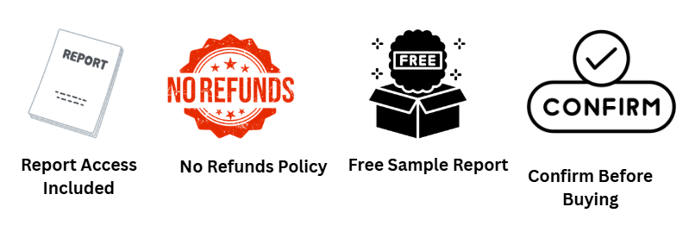
Digital Product Delivery
Research reports, market data files, customized research outputs, and consulting documents are usually delivered in digital format. Delivery may be made through email, secure download link, or another approved digital method.
Once a digital report or research document has been delivered, accessed, downloaded, or shared with the buyer, it is generally considered fulfilled. Due to the nature of digital research products, such purchases are usually non-returnable.
Refund Eligibility
A refund may be considered only in limited cases. This may include duplicate payment, incorrect billing, non-delivery of the purchased report, or failure to provide access after successful payment.
A refund request may also be reviewed if the delivered file is damaged, incomplete, or significantly different from the purchased report description. In such cases, we may first offer a corrected file, replacement copy, or suitable resolution.
Non-Refundable Cases
Refunds are generally not provided after a report has been delivered, downloaded, accessed, or used. Refunds are also not applicable when the client changes their mind after purchase, no longer needs the report, or expected different results from the analysis.
Customized research projects, consulting assignments, paid analyst calls, data extraction work, and specially prepared deliverables are usually non-refundable once work has started. These services require time, research effort, expert review, and resource allocation.
Cancellation Policy
Orders for ready-to-purchase reports may be cancelled only before the report is delivered or accessed. Once delivery has been completed, cancellation may not be accepted.
For custom research or consulting projects, cancellation terms will depend on the project stage, agreed scope, and work already completed. Any approved refund may be adjusted against research hours, administrative costs, third-party data costs, and completed deliverables.
Report Replacement
If a user receives the wrong report, damaged file, incomplete document, or access issue, we will review the concern and provide a suitable replacement where applicable. The request should be made within [3 business days] from the date of delivery.
Clients are advised to check the report title, scope, table of contents, license type, and delivery details before purchase. Our team may assist with pre-purchase questions to help users select the right report.
Processing of Approved Refunds
If a refund is approved, it will be processed through the original payment method or another mutually accepted method. The time required for refund credit may depend on the payment gateway, bank, card issuer, or financial service provider. Any taxes, transaction fees, currency conversion charges, or bank deductions may be handled as per applicable payment terms and local rules.
How to Request a Refund or Support?
To request support, cancellation, replacement, or refund review, users must contact us with the order ID, payment details, report title, date of purchase, and reason for the request.
Contact Us
Globe Market Research
Email: admin@globemarketresearch
Website: https://www.globemarketresearch.com
Each request will be reviewed fairly based on the order status, delivery record, product type, and applicable terms.

Terms and Conditions
Welcome to Globe Market Research. These Terms and Conditions govern the use of our website, research reports, market intelligence products, consulting services, custom research solutions, and related business services.
By accessing our website, purchasing a report, requesting a sample, using our services, or communicating with our team, users agree to these Terms and Conditions. Users who do not agree with these terms should not use the website or purchase our services.
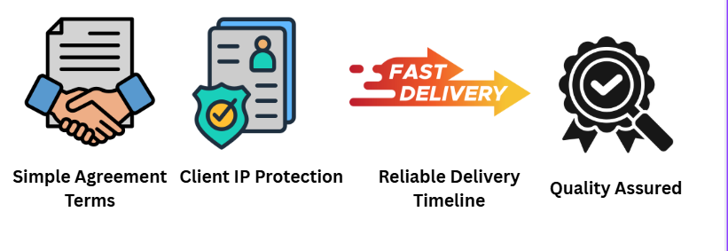
Nature of Our Services
Globe Market Research provides industry reports, syndicated research, custom research, consulting support, market data, competitive analysis, and business intelligence services. Our research is intended to support business planning, strategic assessment, market understanding, and decision-making.
The information provided in our reports is based on available data, research methods, industry sources, expert analysis, and market interpretation. Market conditions may change due to economic, regulatory, technological, political, competitive, or industry-specific factors.
Use of Website
Users agree to use the website only for lawful and professional purposes. Users must not misuse the website, attempt unauthorized access, copy website systems, interfere with security features, or upload harmful material.
The website content is provided for general information and business reference. We may update, change, suspend, or remove any part of the website without prior notice.
Report Purchase and Delivery
Users are responsible for reviewing the report title, description, coverage, table of contents, license type, price, and delivery details before placing an order. Once payment is completed, the report may be delivered by email, download link, or another approved digital method.
Delivery timelines may vary depending on the product type, payment confirmation, customization needs, and internal verification process. Any estimated delivery timeline is provided for guidance and may be affected by technical or operational reasons.
Pricing and Payment
All prices are listed in the applicable currency as shown on the website, proposal, invoice, or order page. Prices may change without prior notice unless already confirmed in a written proposal or invoice.
Payments must be completed through the approved payment methods provided by Globe Market Research. Any taxes, bank charges, currency conversion costs, or payment gateway fees may be the responsibility of the buyer unless clearly stated otherwise.
Intellectual Property Rights
All reports, data tables, charts, analysis, website content, graphics, research materials, documents, and related content are the intellectual property of Globe Market Research or its authorized content partners.
Users may not copy, resell, publish, distribute, upload, reproduce, modify, transfer, or commercially exploit any report or content without written permission. Access to a report does not transfer ownership of intellectual property rights to the buyer.
License and Usage Restrictions
Reports are provided under the license type selected or agreed at the time of purchase. A single-user license, multi-user license, corporate license, or enterprise license may have different usage rights.
Users must not share reports beyond the permitted license scope. Unauthorized sharing, resale, public posting, or redistribution may result in access restriction, legal action, or additional license charges.
Accuracy and Research Limitations
We make reasonable efforts to provide accurate, timely, and useful research. However, market research involves estimates, assumptions, forecasts, and interpretations based on available information at the time of preparation.
Future market values, growth rates, company performance, technology adoption, demand trends, and investment outcomes may differ from projections. Users should apply their own judgment before making business, investment, financial, or strategic decisions.
No Financial or Legal Advice
Our research reports and consulting outputs are provided for informational and business research purposes only. They should not be treated as legal, tax, accounting, investment, medical, or financial advice. Users should consult qualified professionals before making decisions that require legal, financial, regulatory, technical, or investment advice.
User Responsibilities
Users must provide accurate information when placing orders, requesting services, or communicating with our team. Users are responsible for ensuring that purchased reports or services meet their business needs before completing payment.
Users must not use our content for misleading claims, unlawful activity, unfair competition, unauthorized redistribution, or any purpose that may damage the reputation or rights of Globe Market Research.
Third-Party Information
Our reports may include references to publicly available information, company disclosures, industry databases, government publications, trade sources, expert inputs, and third-party data sources. Such information is used for research and analysis purposes. We do not control third-party sources and cannot guarantee that all external information will remain current, complete, or unchanged after publication.
Limitation of Liability
Globe Market Research will not be liable for any direct, indirect, incidental, financial, business, or consequential loss arising from the use of our website, reports, data, forecasts, or services. Users are responsible for how they interpret and apply research findings. Our total liability, where legally applicable, shall not exceed the amount paid by the user for the specific product or service giving rise to the claim.
Confidentiality
For custom research, consulting projects, and client-specific work, we aim to maintain confidentiality of client-provided information. Any specific confidentiality requirement should be agreed in writing before project commencement. Users must also maintain confidentiality of any non-public material, proposal, pricing, methodology, or custom deliverable shared by Globe Market Research.
Refunds and Cancellations
Refunds, cancellations, and replacements are governed by our Return Policy. Users are advised to review the Return Policy before purchasing any report or service. Digital research products are generally non-returnable once delivered, accessed, downloaded, or used.
Changes to Terms
We may update these Terms and Conditions from time to time. Any changes will be posted on this page with an updated effective date. Continued use of the website or services after changes are posted will be treated as acceptance of the revised terms.
Contact Us
For questions about these Terms and Conditions, users may contact:
Globe Market Research
Email: admin@globemarketresearch.com
Website: https://www.globemarketresearch.com

